DIRECTV Bargaining Bulletin #2

November 2, 2021

Bargaining continued last week between the CWA and DIRECTV committees. The Union Bargaining Team continues to wait for DIRECTV to respond to a number of information requests submitted by the union team over the last couple of weeks. The requested information is vital for the union to formulate proposals to continue our fight for improved job security, working conditions, wages and benefits for CWA members at this new company. The union team is reevaluating several issues in an attempt to find common ground on a consolidation of contracts that cover CWA members at DIRECTV nationwide.

While we’re negotiating with the Company all existing contractual agreements will be honored and remain in full effect as is and we’ll continue to bargain with DIRECTV.

In Unity,

Sylvia J. Ramos, Assistant to the VP, District 6
Mary Jo Reilly, Staff Representative, Telecommunication & Technologies
Pat Telesco, Area Director, District 1
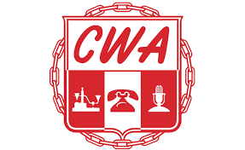
Angela Wells, Administrative Director, District 3
Herman Junkin, Jr., Staff Representative, District 3
Ron Gay, Jr., Staff Representative, District 4
Tony Shaffer, Staff Representative, District 6
Domonique Thomas, Assistant to VP, District 9

UNITED WE BARGAIN … DIVIDED WE BEG!!!
sv/opeiu#13

